Gender Equality Club Curriculum – Gender and Work, Ethiopia

Developed by Nicole Cristobal
As a part of the GEC team w/
Ciera Young and Jawanza Rand

Overview:
This curriculum was created off of field work (interviews, observations, filed notes) conducted in Wolaita-Sodo, Ethiopia over the course of four weeks as part of the 2017 Fulbright Hays Ethiopia Curriculum project in combination with secondary sources. This is intended to be used in Gender Clubs throughout the U.S. to teach students the ways in which gender is manifested in work, both in the home and outside of the home, in a culture that differs from their own.

Learning Objectives:
For students to think critically about how work is gendered in Ethiopia.
For students to gain awareness into the ways work is gendered in their own sociocultural positioning in comparison to that of Ethiopia.

Teacher Preparation: (tools/materials)
Gender and Work, Ethiopia lesson
Gender and Work, Ethiopia—A Day in the Life Worksheet

Instruction:
- Introduce the lesson by reviewing Gender and Work, Ethiopia lesson.
- Distribute Gender and Work, Ethiopia—A Day in the Life Worksheet.
- Ask students to fill out the left half of the worksheet.
- Discuss with students what they wrote, challenging them wherever necessary, to think about their role in each task (i.e. “Eat breakfast” can be followed-up with prompting about what they eat for breakfast, who prepares it, how long it takes to eat breakfast, etc…).
- Have students fill out the right half of the worksheet with how they think an Ethiopian girl of their same age would answer the questions.
- Discuss with students their responses, having them reflect on similarities and differences between gender expectations in work in their culture and in Ethiopian culture.

Attachments:
Gender and Work, Ethiopia lesson (attachment 1)
Gender and Work, Ethiopia—A Day in the Life Worksheet (attachment 2a).
Gender and Work, Ethiopia —A Day in the Life Worksheet example (attachment 2b).
Gender and Work, Ethiopia, pictures (attachments 3a-9a).

Attachments:

Attachment 1: Gender and Work, Ethiopia Lesson
Constitution of the Federal Democratic Republic of Ethiopia
Articles 41 and 42:
Every Ethiopian has the right to choose his or her means of livelihood, occupation or profession (41-2).
Women workers have the right to equal pay for equal work (42-d).
- Household work:
  - Household work is divided along gender lines.
  - Women and girls hold a disproportionate amount of household responsibilities compared men and boys.
    - “ ‘No this is not our work, we are men,’ they say then their father says, ‘yes, they are correct.’ Yeah, he supports them, encourages them.”
-Ethiopian Primary School Teacher on the refusal of her sons in doing housework
  - Women are responsible for fetching water, cooking, making coffee, cleaning, doing laundry, and child rearing.
    - In-door plumbing systems are rare in Ethiopia, so often times, water must be fetched from a nearby well/ water station. Women and girls use plastic containers to fetch water (see Attachments 3a and 3b).
    - In a typical Ethiopian home, meals largely consist of vegetables with bread or enjera. Enjera is made from a seed grass called Teff. Women and girls will combine teff flour with water and stir until it is smooth. After allowing it to ferment for a few days, they will add salt and cook thin layers of it in a skillet until it forms small holes. Once it is cooled, it is served with vegetables and other food items. Enjera is a staple in the Ethiopian diet. Vegetables are often grown in personal gardens or bought at the local market and commonly include, cabbage, lentils, tomatoes, garlic, and onions. Fruits and other snack items are also served throughout the day. (see attachments 4a-4f).
    - Making and drinking coffee is a pillar of Ethiopian culture. Ethiopians will hold what is called a “coffee ceremony,” up to three times a day. This consists of women and girls lighting incense, roasting coffee beans on an open coal fire, grinding the coffee beans by hand, heating the coffee in homemade coffee pots over a coal fire, and serving the coffee with sugar in small cups. Roasting popcorn is also a common component of coffee ceremonies. (see attachments 5a-5e).
    - Laundry is done by hand, where clothes are soaked with soap in large buckets, wrung out and put on clothes lines to dry (see attachments 6a-6b).
    - It is common to see women holding their children when engaging in house work. It is also common to see older female siblings caring for young siblings, while also helping their mothers with housework (see attachments 7a-7b).
  - The amount of housework women and girls are expected to do contributes to their underrepresentation in the workforce and to their attrition in school.
    - “They come to school at that time sleeping in class. To avoid this we make the program. The gender issue program and we can change some things.”
-Ethiopian Primary School Teacher
    - “At that time I was pregnant. I asked to withdraw from my program.”
-Ethiopian Primary School Teacher
  - Many women and girls who aspire to continue their education or gain employment are met with resistance from family.
    - “My husband forced me, that means I needed to drop he said. Not give a chance to take any control or plan so for years I [birthed children].”
-Ethiopian Primary School Teacher on withdrawing from college to fulfil her expectations as a wife/ mother.
  - Men are the primary decision-makers for the family.
    - “My mother suffered a lot because of my father, because he made all the decisions.”
-Ethiopian University Professor
- Work Outside of the Home:
  - Women are underrepresented in formal employment because of gender role expectations and the lack of education and resources.
  - Women are typically funneled into low-paying jobs.
  - Although there is an equal pay for equal work law in place, women earn 86% of what men earn on average (Ministry of Women’s Affairs, 2006).
  - Women find informal employment through making and selling goods in the market or on the streets and through engaging in local enterprise, such as spinning cotton for sale in the textile industry (see attachments 8a-8c).
  - Many women are financially dependent upon their husbands because of low wages and unemployment.
  - Women’s employment is often decided by government systems related to education.
    - “It wasn’t my decision to teach. The ministry of education assigned me to the English department.”
-Ethiopian University Instructor
C. Work being done in Ethiopian communities to address issues resulting from gendered work:
a. Gender Equality Clubs in primary schools in Ethiopia:
i. Facilitated by a volunteer female teacher.
ii. A safe space exclusively for girls to discuss issues pertinent to them as females in Ethiopian society.
iii. A place to get resources (i.e. modus).
iv. A source of support in female student retention and success in academia.
“I encourage, always…You are equal with men. We have equal opportunities at this time, because all peoples, men and women, we are equals. So you will be doctor, you are to be a pilot or engineer, so we are equal I say.”
-Ethiopian Teacher/ Gender Club facilitator
b. Non-profit organizations:
i. WRAPSforGirls foundation (for more information: https://www.facebook.com/WRAPSforgirls/).
ii. Employs an all female, Ethiopian staff to make and distribute reusable pads to girls in rural parts of Ethiopia to support their retention in school (see attachment 9).
Reference:
Ministry of Women’s Affairs. (2006). National Action Plan for Gender Equality. Addis Ababa,
Ethiopia. Retrieved September 19, 2017 from: http://extwprlegs1.fao.org/docs/pdf/eth149708.pdf.

Attachment 2a: Gender and Work, Ethiopia—A Day in the Life Worksheet
The things that I do during a typical day: | The things that a girl my age in Ethiopia would do during a typical day:
What I want to be when I am an adult: | What a girl in Ethiopia who is my age would want to be when she is an adult:
What is stopping me from achieving my dreams: | What is stopping a girl in Ethiopia, my age from achieving her dreams:

Attachment 2b: Gender and Work, Ethiopia Worksheet Example
The things that I do during a typical day:  Wake up  Brush my teeth  Eat breakfast  Go to school  Go home  Do chores  Go on social media  Hang out with friends  Shower  Eat dinner  Sleep | The things that a girl my age in Ethiopia would do during a typical day:  Wake up  Make breakfast  Make coffee (roast coffee beans over coal fire, hand grind coffee beans, make coffee in coffee pot over coal fire, serve coffee)  Serve breakfast and coffee to family  Walk younger siblings to school  Go to school  Go home and watch younger siblings  Make food for younger siblings  Serve food to siblings  Wash clothes  Make dinner and coffee  Go to sleep
What I want to be when I am an adult:  Veterinarian | What a girl in Ethiopia who is my age would want to be when she is an adult:  Doctor
What is stopping me from achieving my dreams:  Grades in school | What is stopping a girl in Ethiopia, my age from achieving her dreams:  Balancing house work responsibilities with school responsibilities  Expectation to drop out of school and get married and have kids  Not having a lot of female role models who are doctors

Attachment 3a:
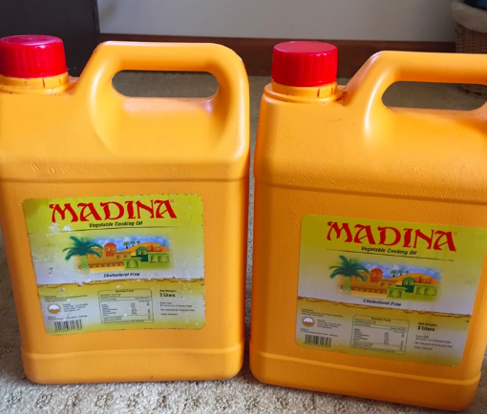
Plastic containers used to fetch water.

Attachment 3b:
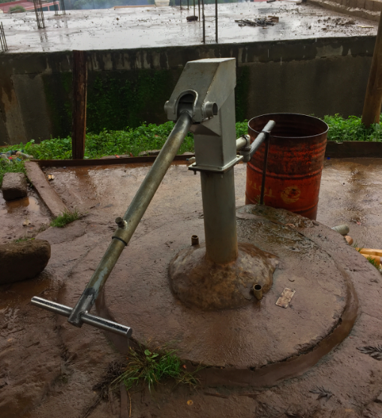
Water station pump.

Attachment 4a:
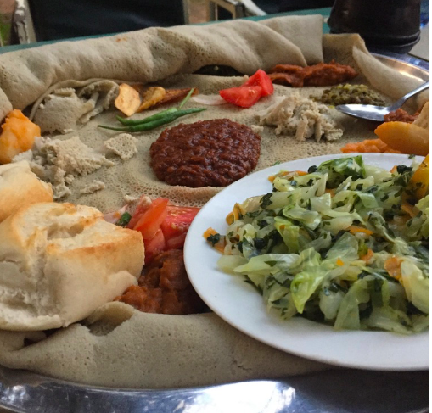
Typical Ethiopian meal. Enjera is used as a platter for the rest of the food to sit on. It is also used to pick up and eat the other foods on the tray.

Attachment 4b:
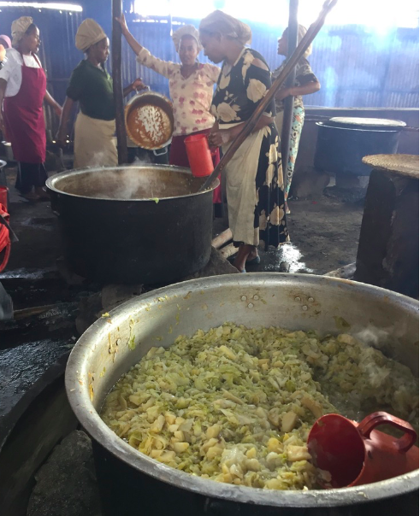
Women preparing a large number of meals for students at a local university.

Attachment 4c:
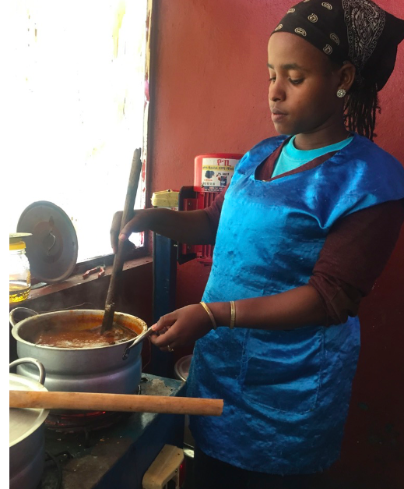
Woman cooking an Ethiopia dish called, Shirwat at a local university.

Attachment 4d:
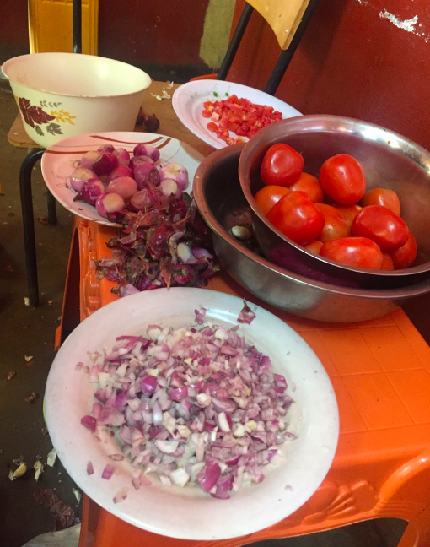
Common ingredients seen in Ethiopian cuisine.

Attachment 4e:
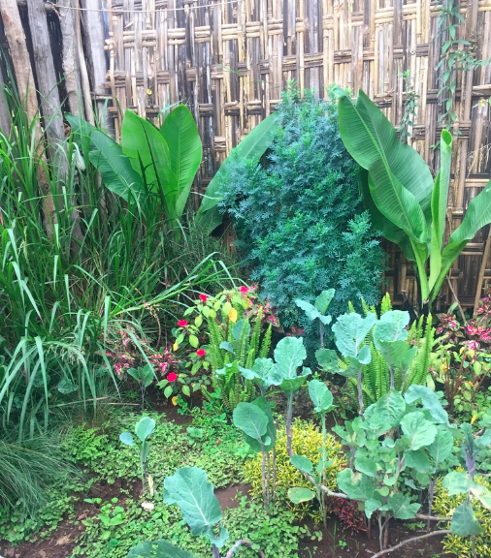
A garden outside the home of an Ethiopian family

Attachment 4f:
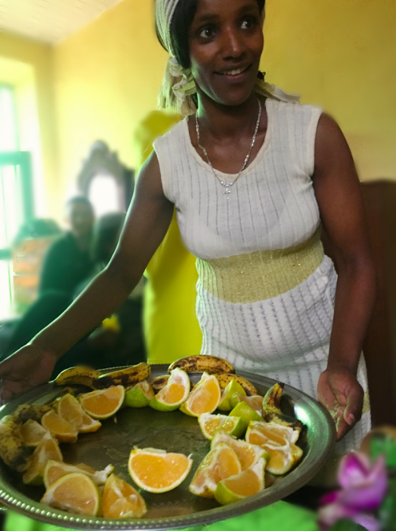
A woman serving fruits as a snack accompaniment with coffee.

Attachment 5a:
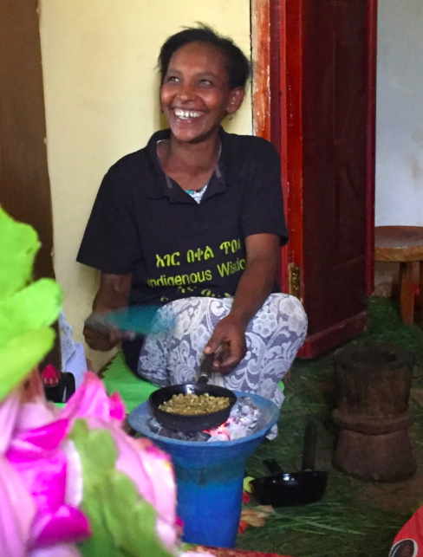
A woman roasting coffee beans.

Attachment 5b:
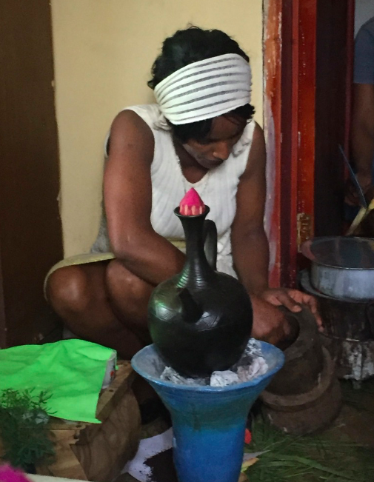
A woman scooping out coffee grounds to fill the coffee pot.

Attachment 5c:
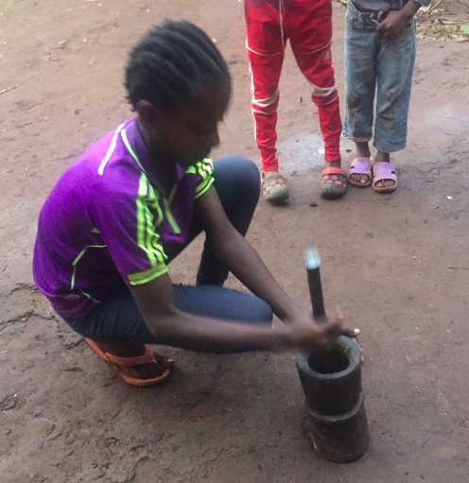
A girl grinding coffee.
Attachment 5d:
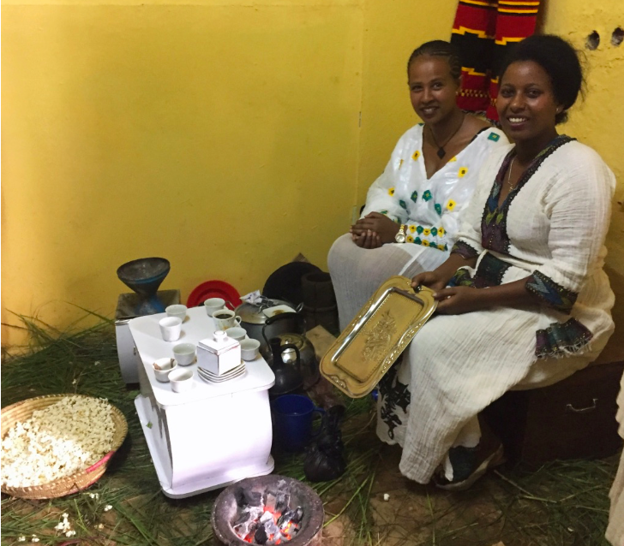
Two women holding a coffee ceremony.

Attachment 5e:
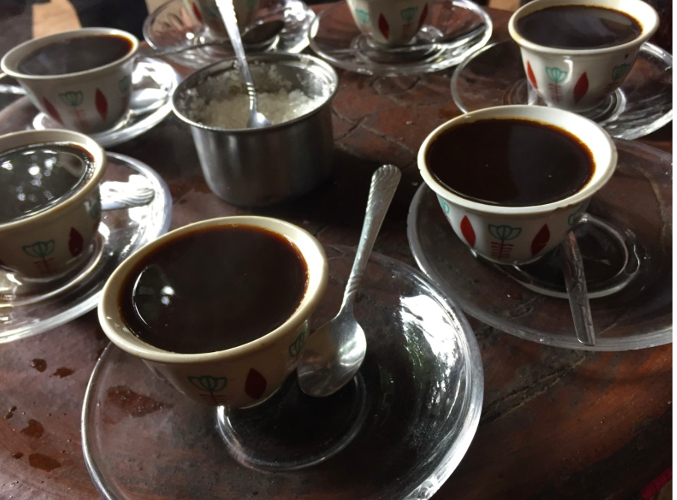
Coffee is served in small cups with coarse sugar. Drinking coffee is a group activity, where several people in a family or community come together to share in each other’s company.

Attachment 6a:

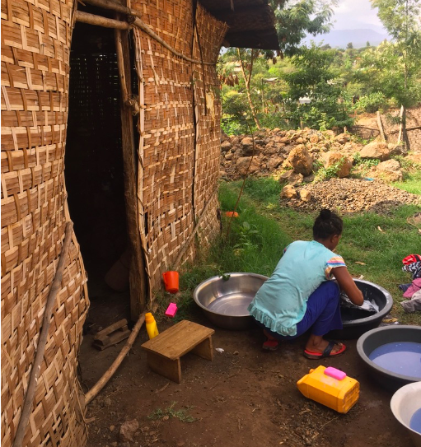
A woman washing clothes.

Attachment 6b:
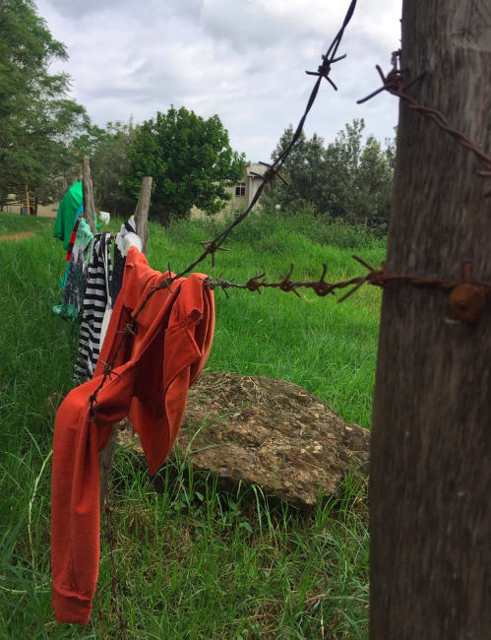
Clothes hanging out to dry.

Attachment 7a:
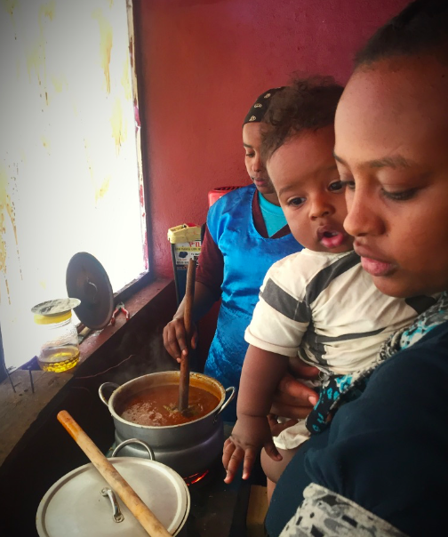
Women caring for children while cooking.

Attachment 7b:
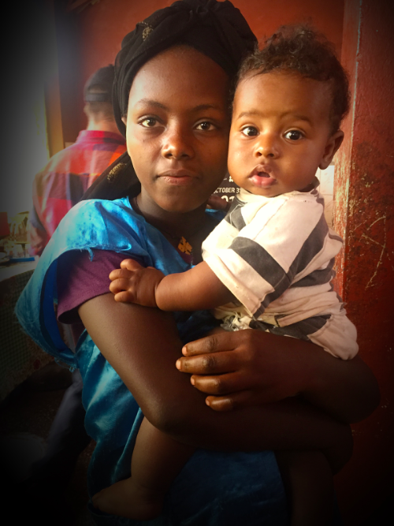
Girl caring for her younger sibling while helping her mother cook.

Attachment 8a:
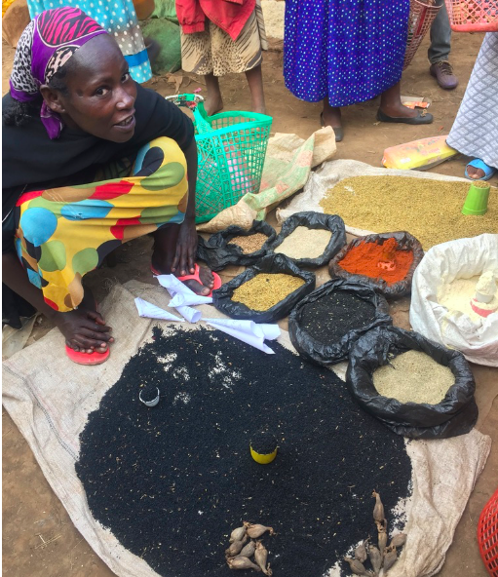
Woman selling grains at the local market.

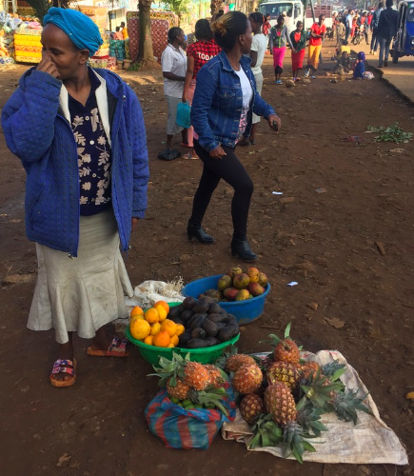
Woman selling fruits on the street.

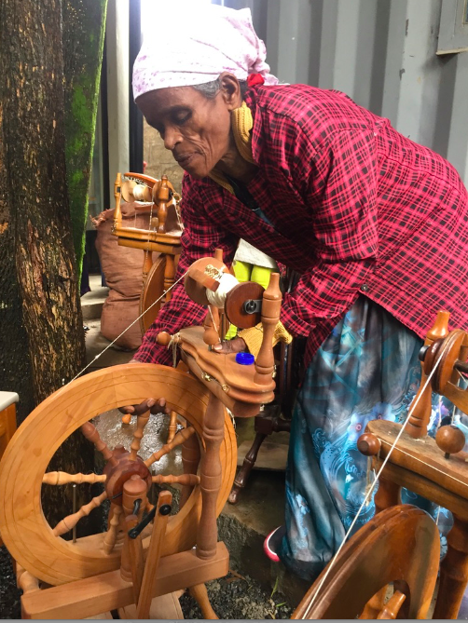
Woman spinning cotton at the Sabahar factory in Addis Ababa, Ethiopia

Attachment 9a:
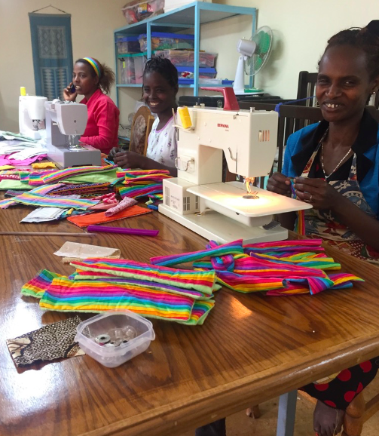
Women sewing reusable pads at the WRAPS foundation workshop in Sodo, Ethiopia to support girls’ retention in school.

