Everyday Objects in Ethiopia and the United States
Grades: 5-8 (Adaptations can be made elementary school students)
Focus: The students will learn about “everyday objects” which are used in Ethiopia. Students will study the object in-depth looking at how it is made and why it is used. Most of the items are used on a daily basis in each country, but look and function differently from each other. The focus is for students to see the similarities and differences between the everyday objects used both in the United States and Ethiopia.
Number of Lessons: 1 – 15 (depending on how many lessons are combined or used. Lessons can be taught individually or grouped together in stations. If using stations, the recommendation is to use the lessons for four or five of the objects at one time.)
Why Important: These lessons are important because they will expose students to other designs of everyday objects while getting them to consider why there are variations. It will show students that not everything is machine-made or hand-made and some of the objects people throw in the trash might actual have value to others.
At the end of the lesson, students will realize that all humans have some things in common. Some of these things include 1) The need for food, shelter and water, 2) The desire for beauty, 3) The wish to simplify tasks and 4) The obligation to work with what resources are available.
Lesson Plans –
Title for Each Lesson (Station):
1. Shopping Bags
2. Scarves
3. Sifters/Colanders
4. Coffee Pots
5. Wooden/Metal Objects
6. Flags
7. Toys
8. Bottle Labels
9. Toothbrushes
10. Coffee Grinders
11. Modes of Transportation
12. Shoes
13. Money
14. Lawn Mowers
15. Cell Phones

National/State Standards –
-Common Core Literacy Standards
CCSS.ELA-LITERACY.RI.8.7
Evaluate the advantages and disadvantages of using different mediums (e.g., print or digital text, video, multimedia) to present a particular topic or idea on Core Literacy Standards
CCSS.ELA-LITERACY.RST.6-8.9
Compare and contrast the information gained from experiments, simulations, video, or multimedia sources with that gained from reading a text on the same topic.
-Pennsylvania State Social Studies Standards (Note: This Lesson applies to most states’ eighth grade Social Studies Standards)

7.3.9.B. Explain the human characteristics of places and regions by their cultural characteristics

7.3.9.D. Explain the human characteristics of places and regions by their economic activities.
(Note: These are only sampling of national and state standards met by this lesson. Educators are encouraged to use standards that are specific for their own curriculum requirements)

Technical Tools Needed –
- If choosing to view the documents on a computer, teachers will need computers or a SmartBoard to project photos of the objects.
- Ethiopian Expedition Video for Introduction/Conclusion (Video link provided below)

Expectations/Goals –
- Students will describe different means and methods for making objects that do not require machines.
- Students will generalize and make basic observations on Ethiopian culture based on their knowledge of the Ethiopian objects.
- Students will list advantages and disadvantages of different methods of object production.
- Students will specify the characteristics and practices found in American and Ethiopian cultures.

Essential Questions –
- What are the similarities and differences between objects made in Ethiopia and the United States?
- Despite the differences in how objects are made, what similarities exist between American and Ethiopian cultures?
- What are the advantages and disadvantages to making things by hand?
- What are the advantages and disadvantages to making things by machine?

Background Needed for Teacher – Extensive knowledge about Ethiopia is not necessary to complete this lesson. The answer key provides enough knowledge to complete this lesson successfully. It is recommended that the teacher view the Ethiopian Expedition video for some basic information.

Lesson Procedure –
(Notes: Lessons may be slightly different based on if completing each lesson individually or grouped into stations. The lesson is more complete if all objects on the list are analyzed. However, lessons can be shortened to meet classroom needs. It is also highly recommended to obtain a University of Pittsburgh Artifact box. Please see directions listed in Pedagogical attachments.)
- If choosing to use the Ethiopian Expedition Objects Video at the beginning of the lesson, show it now. Remind students to pay special attention to objects that Ethiopians may use every day. There is a study guide of questions for the video, if choosing to get further in-depth about community life with the students.
- Choose one set of objects to complete/analyze (Ethiopian or American). For Americans, it is highly recommended to start with the Ethiopian set of objects; Ethiopian educators should start with the American set of objects.
- Hand out answer sheets. Students should study each picture closely and answer each question to the best of the best of their ability. If grouping objects into stations, the following list is recommended:
Day #1  Objects to group together:  1. Weaving  2. Looming  3. Basket/Sifter  4. Pottery  5. Wooden Objects | Day #2  Objects to group together:  1. Transportation  2. Shoes  3. Money  4. Lawn Mower  5. Cell Phones | Day #3  Objects to group together:  1. Flag  2. Toys  3. Drink Labels  4. Toothbrushes  5. Mortar & Pestle / Food Processor

- When students have finished analyzing each object as a class, have students discuss why they reached their conclusions. Share the answer sheets. (Note: This answer sheet was composed by a group of Ethiopian female educators). This can be done as small groups or as a whole class.
- Hand out the picture set of the opposite group of objects (either the Ethiopian or American). Students should match the object to its opposite counterpart. For example, the American flag matches the Ethiopian flag; the plastic bag matches the woven bag, etc.)
- Students should answer the questions about second set of objects. When finished, students should compare and contrast how the objects are made, what they are made from, and other observations. It is recommended to complete this task by using a Venn diagram or similar graphic organizer.
- Show the Ethiopian Expedition Video (again or for the first time) and have the students use the video to check their answers to the answer sheets of both Ethiopian and American objects. They can also use the video information to draw conclusions for the assessment activity.
Assessment:
Students will fill in a Venn diagram focusing on the major similarities and differences between Ethiopian and American objects. Students should try and focus on major themes in the final Venn diagram (See Sample Below). The recommendation is to have at least four answers in each section. This suggestion can be modified. Depending on time and the personal objectives of the teacher, students can turn their Venn diagram into one compare paragraph and one contrast paragraph.
Students should answer the following essential questions on their own or in a discussion-based format.
1. What are the similarities and differences between objects made in Ethiopia and the United States?
2. Despite the differences in how objects are made, what similarities exist between American and Ethiopian
cultures?
3. What are the advantages and disadvantages to making things by hand?
4. What are the advantages and disadvantages to making things by machine?
Student answers may vary for the Venn diagram and Essential Questions. Teachers should make sure that students can support their claims with evidence from the artifacts.

Sample Venn diagram for student answers:
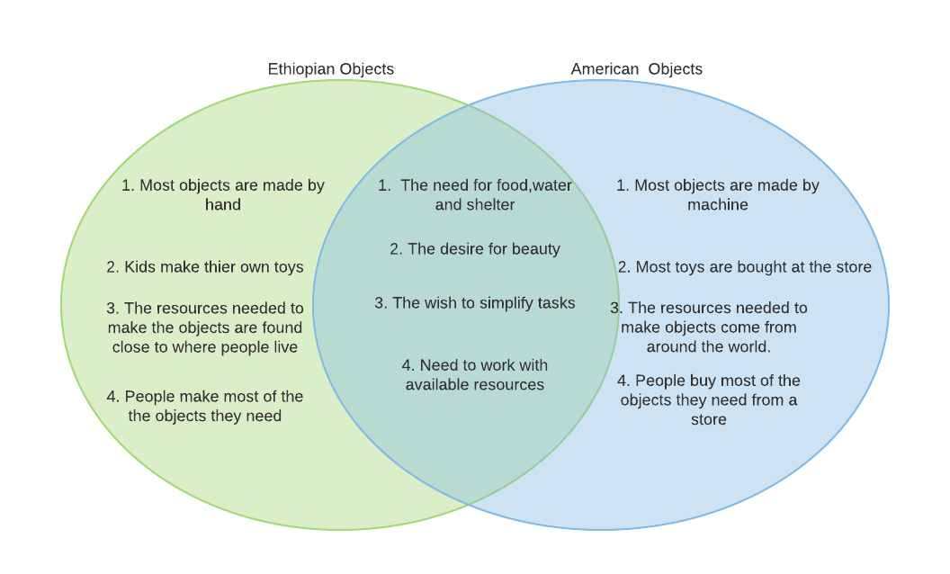

Attachments:
Pictures –
Links to Resources –
Handouts –
- Everyday American Objects Blank Answer Sheet Word Document
- Everyday American Objects PowerPoint
- Everyday American Objects Teacher Answer Sheet Word Document
- Everyday Ethiopian Objects Blank Answer Sheet Word Document
- Everyday Ethiopian Objects PowerPoint
- Everyday Ethiopian Objects Teacher Answer Sheet Word Document
Links to Videos (with short descriptions) – An Ethiopian Expedition: Learn All About Ethiopia! video (https://www.youtube.com/watch?v=klYl6MUYmuc)– This video gives a brief introduction to many Ethiopian topics and items. It teaches how to count, greet people, and what some basic items are and do.
Pedagogical Elements (cards, manipulatives, games) –The majority of objects shown in the pictures are housed at the University of Pittsburgh African Studies Department. If you are interested in obtaining a box of these objects for your lesson, please contact:
African Studies Program
University Center for International Studies
AfricanStudies@pitt.edu
4138 Wesley W. Posvar Hall
Pittsburgh, Pennsylvania 15260
Phone: 412-648-1802

Fulbright Ethiopia: Indigenous Wisdom and Culture
Created by: Geraldine Truog and Kate Van Haren

